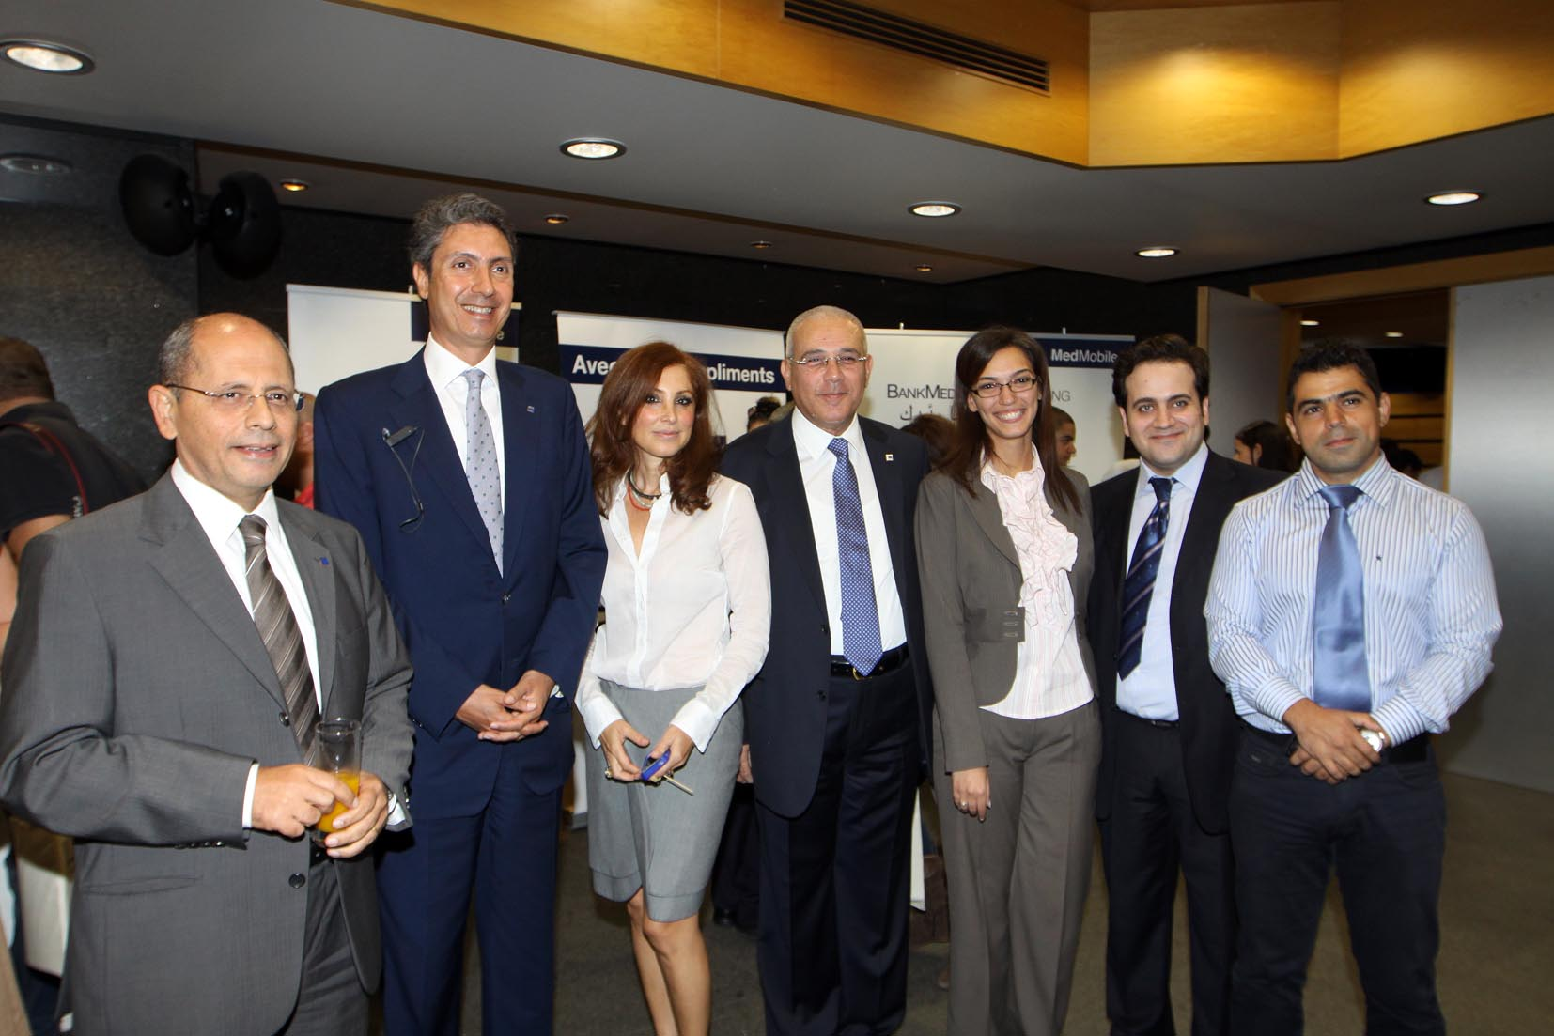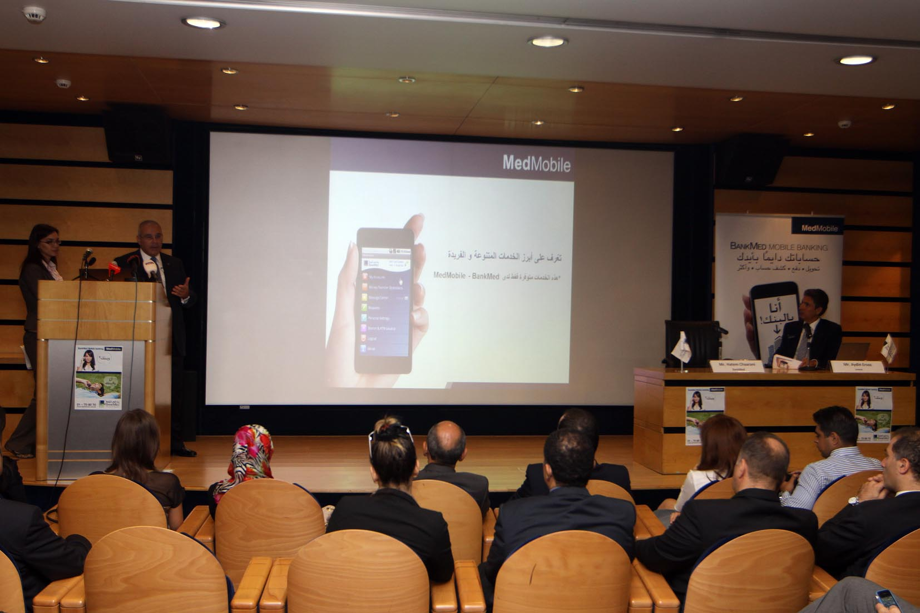

Beirut 30th October 2012

BankMed launches Mobile Banking Application

BankMed held a press conference at the Clemenceau headquarters on October 30, 2012 to announce the launch of “MedMobile”. The newly launched application allows BankMed customers to manage their accounts in a friendly, convenient and secure manner, while on the move.

The MedMobile application has many unique features which do not exist in other similar delivery channels in the market, providing an access to a brief on personal accounts as well as loan and card balance.

It is the only application in the Lebanese market that enables BankMed customers to:
- Manage scheduled and recurring transfers.
- Setup beneficiaries to perform local and international transfers (own and others) at their convenience.
- Inquire on Bancaassurance personal account.
- Access a wide range of card service requests noticeably, update your mobile number for SMS alerts, early credit card renewal, update your card billing address, report for lost or stolen cards and request replacements, and other benefits.
Mr. Hatem Chaarani Division Manager Electronic Delivery Channels & Card Products at BankMed said: “The MedMobile application is a new way for customers to stay at the top of their financial needs in a safe and secure way. The application allows our consumers to utilize our banking services where, when, and how they may need with just a tap on their mobile. This application was developed because banking experience is a key element for us. We have shared this application with over 500 customers who provided us a common feedback: simple, safe, easy and convenient method of banking”
The MedMobile application is easy to download and use designed to work with all type of smart phones, anticipating consumer demand. The application accesses a host of distinctive online services including but not limited to:
•Inquire on any of BankMed services and redeem your earned MedPoints or MedMiles.
•Freedom to stay in touch with BankMed via MedMobile message center and send your requests and feedback.
•Ability to order Checkbook or statement of account.
•Locate your nearest BankMed branches or ATMs with a site map.

Customers are able to register to MedMobile by visiting any of the 57 BankMed branches or by calling 24/7 Call Center at 01-708090.
The MedMobile application was developed by Innova, the IT Services subsidiary of Turkey's largest telecoms operator “Turk Telekom”, to draw attention to BankMed's innovative and exemplary approach to customer service. This collaboration is not new; its translated into several achievements met with a success in developing and promoting retail banking, providing the best services and products to customers designed with the latest technology, such as eKiosk: a self-service interactive electronic kiosk provides access to information and applications, Gift Card and Loyalty Program supported with an online electronic authorization software system, As for the MedMobile; Innova's Co-CEO Aydin Ersoz said ”this application includes security features that are well above the industry standards, offers customers an easy to use solution, and puts important management features in the hands of companies who wish to adopt them”.
Mr. Chaarani added “Our footprints are identified by our competitive strength and this new application “MedMobile” sharpens our focus as a leading retail consumer bank in Lebanon”.

-End-

