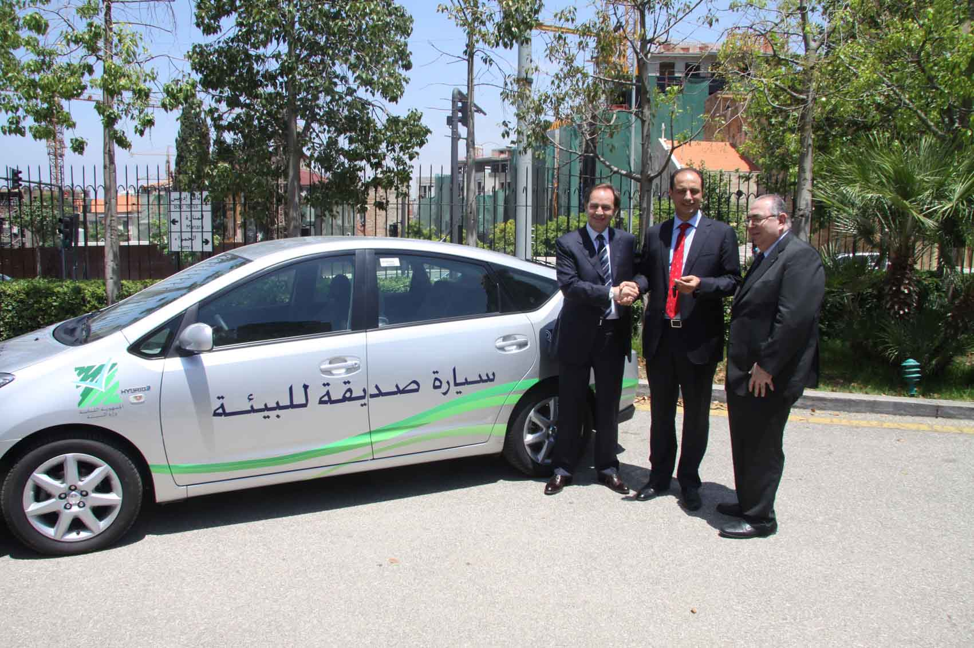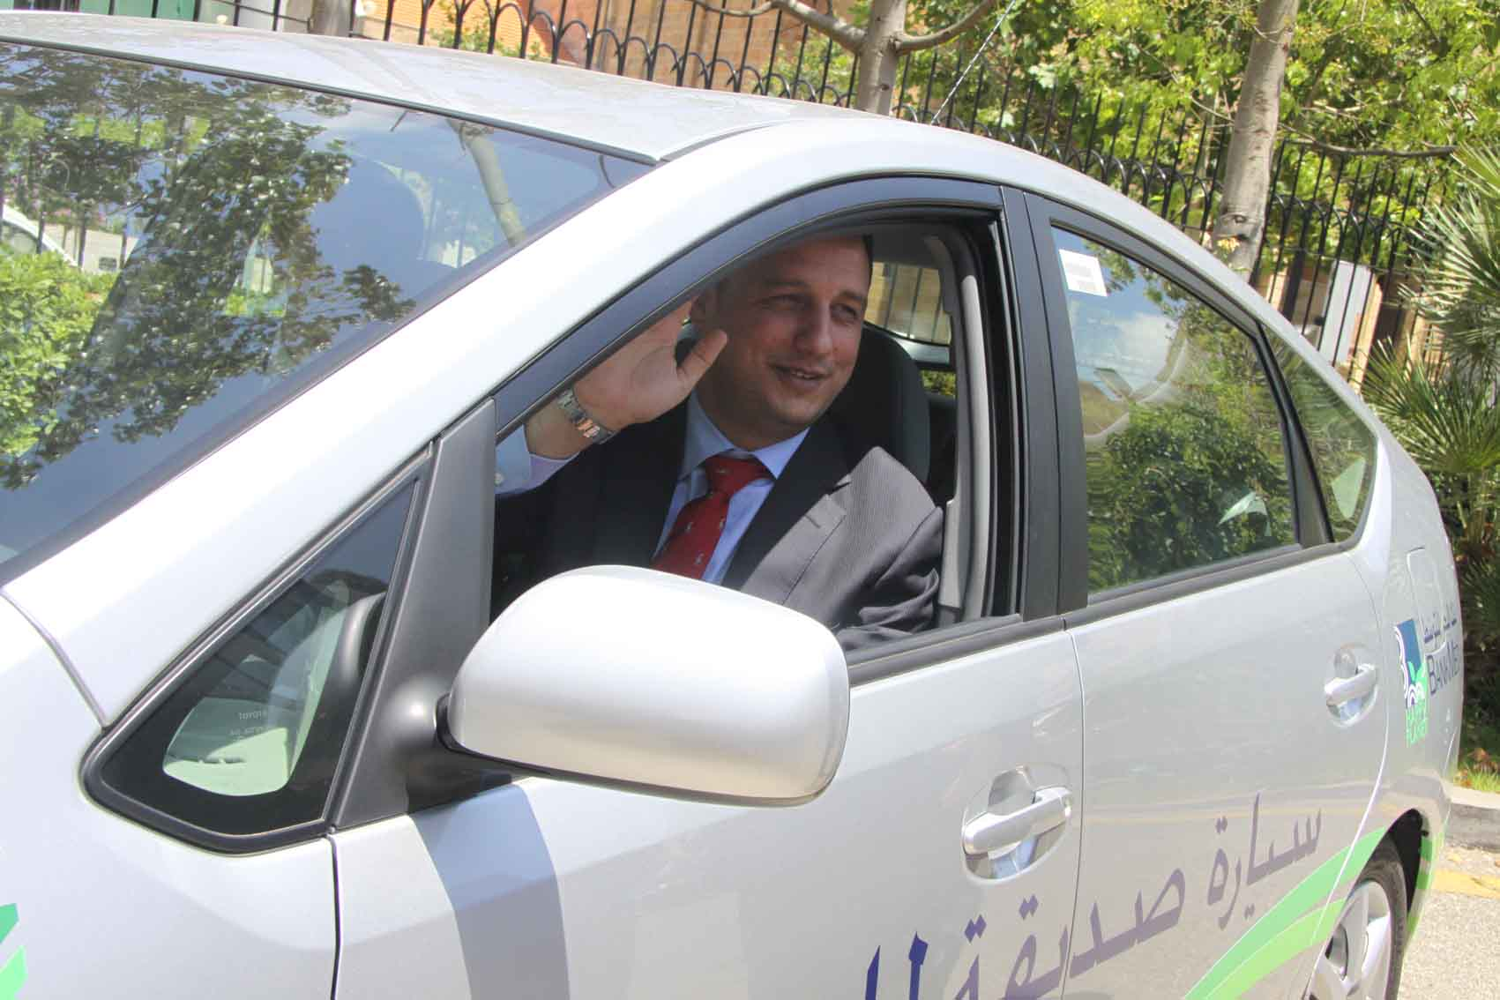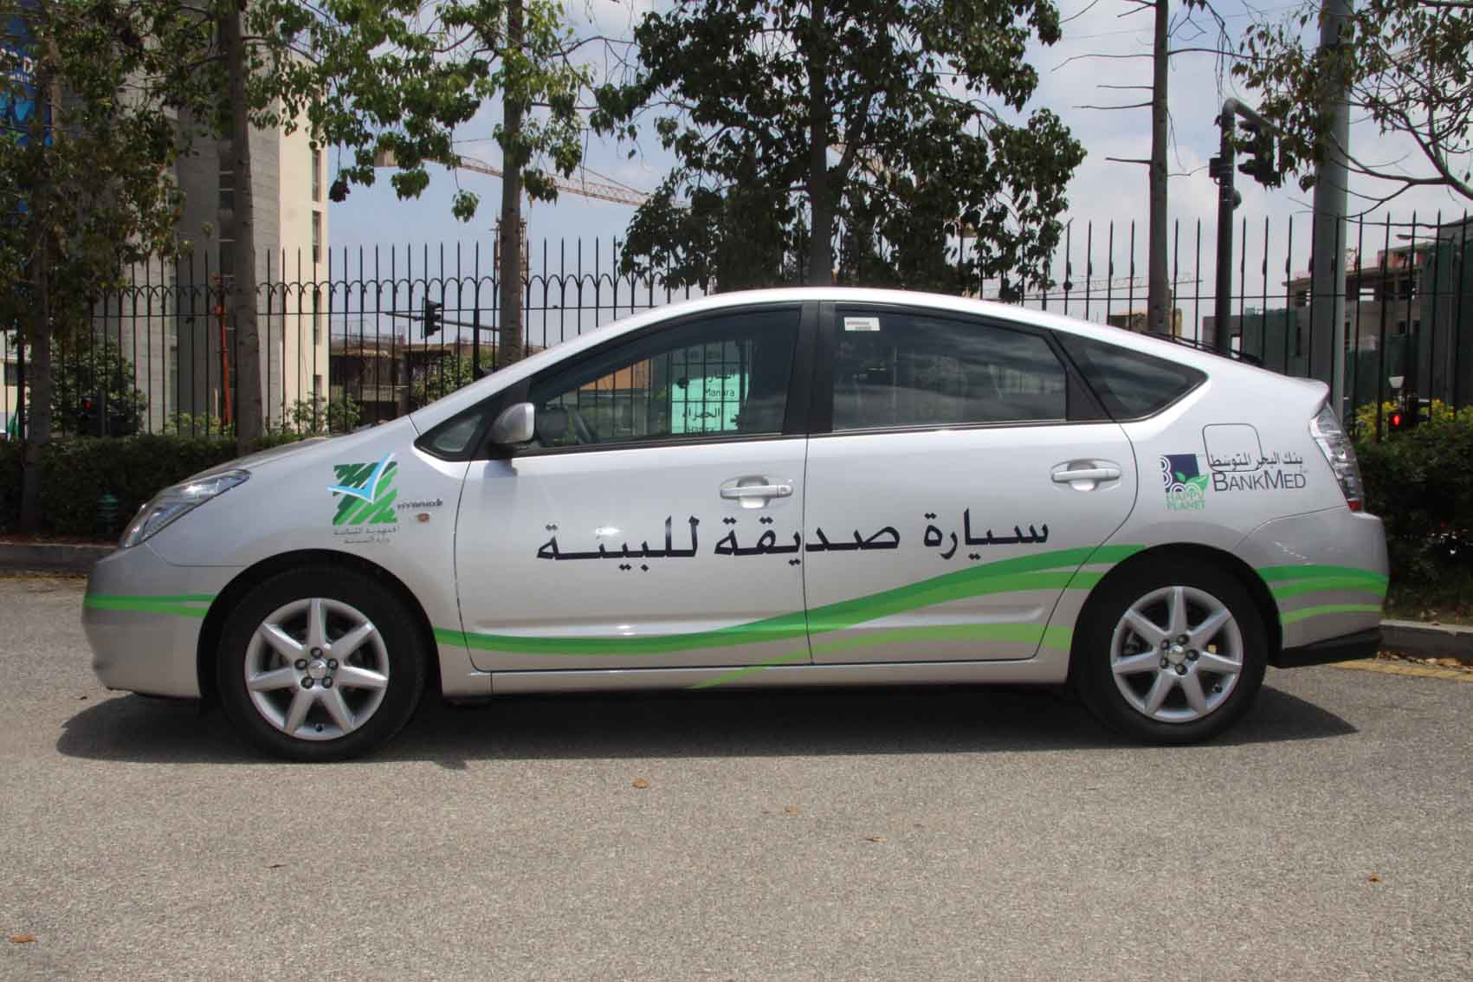

BankMed grants Ministry of Environment a Hybrid car for
all formal events
Beirut, June 30, 2010 – BankMed, as part of their continuous effort towards the environment, have granted the Ministry of Environment, a Toyota Prius Hybrid car, to be used for all formal events. The unveiling of the car took place in a ceremony at BankMed’s headquarters in Clemenceau, in the presence of Minister Rahhal, Mohammed Ali Beyhum, Deputy Executive General Manager from BankMed, amongst other team members from the bank, as well as Dr. Fred and Mr. Pierre Boustany of BUMC, Toyota’s local dealer. This gesture is part of BankMed’s ongoing initiative to give back to the environment.
The type of hybrid vehicle, the Toyota Prius, granted to the Ministry of Environment is in fact the first model hybrid car ever created in the world and the first to enter Lebanon.
In recent years, BankMed has proven its commitment to social and environmental activities by sponsoring and initiating events, across the Lebanese territory. BankMed was the first Lebanese bank to have taken a commitment to assess, measure, and offset its Corporate Headquarters’ carbon footprint. By becoming carbon neutral, BankMed solidifies its position as a leader in Lebanon in taking environmentally friendly initiatives.
“In 2009, BankMed became the first local bank to endorse environmental projects and raise awareness amongst the public,” said Mr. Beyhum on the matter. “We are here today, to continue with our initiative to preserve our environment for future generations,” he said, adding that BankMed is committed to continuing their collaboration with the Ministry of Environment, as has been done in the past.
BankMed launched the ‘Happy Planet’ campaign, which has managed to increase awareness of environmental concerns in Lebanon, while advocating healthy living to maintain a clean, pure and healthy environment for all Lebanese. Many of their initiatives have been carried out with the Ministry of Environment.
Commenting on the generous gift granted to the Ministry of Environment, Minister Rahhal thanked BankMed for their continuous efforts and support over the years, and extended his thanks to those concerned for the environment.
Minister Rahhal also added that plans are underway to lower custom taxes on Hybrid cars in Lebanon, to encourage all citizens to use them.
“What we are trying to do at the Ministry of Environment is to ensure all the activities are unified under one main umbrella of ‘continuous growth’. We are only at the beginning of our journey and we must let our efforts grow in the correct direction,” Minister Rahhal affirmed.
Dr. Boustany of BUMC, shared with the attendees the benefits of the hybrid car, which include: a 50% decreased usage of carbon; 90% less consumption of fuel with one tank allowing the car to travel 450km and lastly the decrease in noise pollution by 6.4% decibels.
“I congratulate BankMed on this innovative initiative,” said Dr. Boustany, who shared with the invitees a history of the car manufacturing sector and hybrid vehicles.
BankMed’s most recent activity was their school initiative, entitled ‘Green School, Green Student’, whereby a competition was hosted across the Lebanese territory, where schoolchildren were invited to submit projects on how to improve the environment, over the course of seven months. This program was launched in 2009, as part of BankMed’s ‘Happy Planet’ campaign. Thousands of submissions came through, composed of scientific projects offering solutions to environmental problems in Lebanon. An awards ceremony held at the bank’s headquarters, gathered the children and prizes were given for the best projects.
The ‘Happy Planet’ initiative was developed by Mr. Mohammed Hariri, Chairman – Genaral Manager of BankMed, in order to support environmental activities, to ensure a better world for future generations.
This initiative is part of the many activities that BankMed has carried out, as part of the Bank's corporate social responsibility program and their continuous efforts towards the environment.

